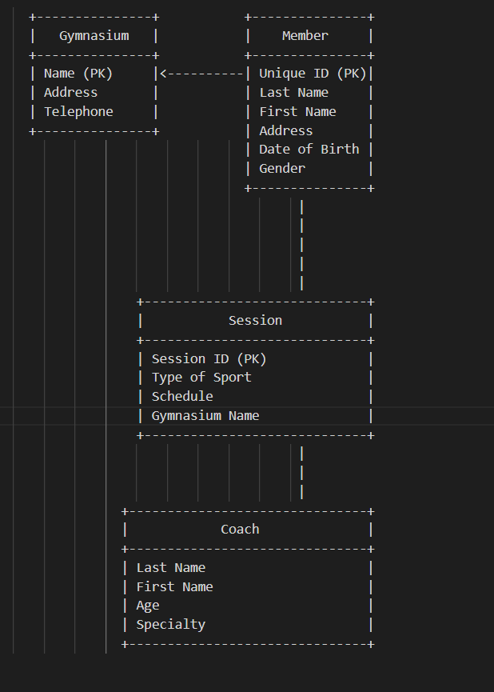

**Entities:**

***1-* Gymnasium** : Name (Primary Key) / Address / Telephone Number .

***2-* Member** : Unique Identifier (Primary Key) / Last Name / First Name / Address / Date of Birth / Gender

***3-*** **Session**: Session ID (Primary Key) / Type of Sport / Schedule / Gymnasium Name (Foreign Key referencing Gymnasium)

***4-*** **Coach**: Last Name / First Name / Age / Specialty

***Relationships:***

**1- Gymnasium - Session (One-to-Many):**

A gymnasium can have multiple sessions.

A session can be associated with only one gymnasium.

**2- Session - Member (Many-to-Many):**

A session can have multiple members.

A member can participate in multiple sessions.

**3- Session - Coach (Many-to-Many):**

A session can have multiple coaches.

A coach can be assigned to multiple sessions.